DA-2020/52s8

**Attachment 1 – Aerial photograph**

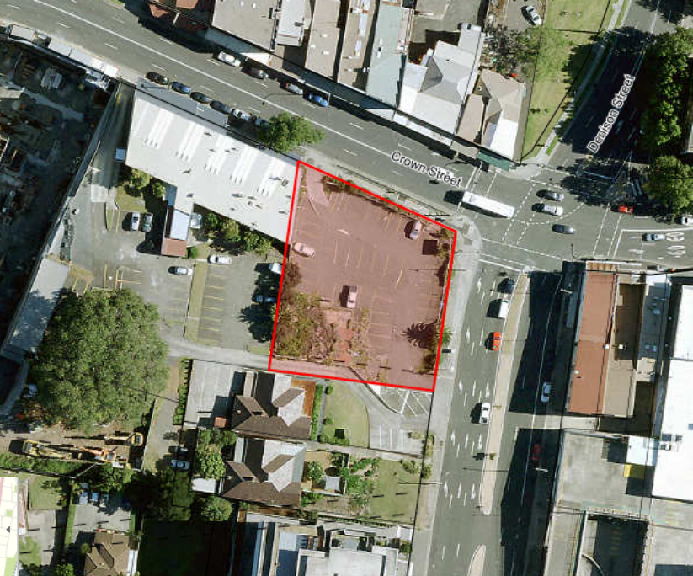

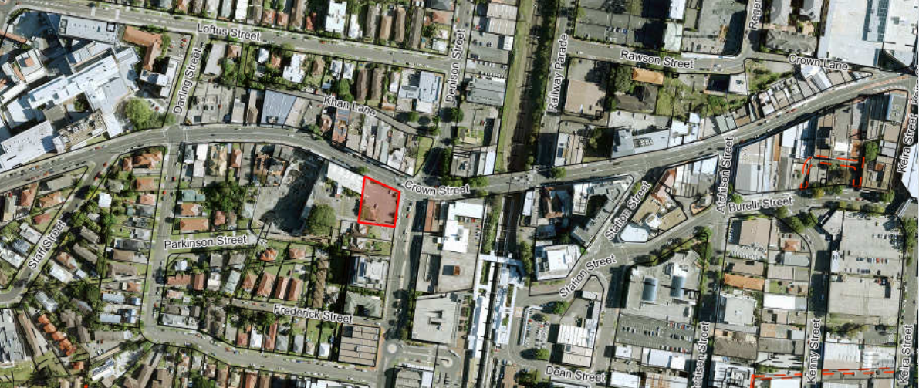

**Mall**

**Wollongong Hospital**

**Wollongong Train Station**